METVY_WORK_SHEET

**NAME** : RAHUL VARMA

# Question 1:

list1 = [1, 2, 3, 4, 5]

print("Question 1: ")

print("List before Swapping: ")

print(list1)

def swap_first_last(lis):

a = len(lis)

temp = lis[4]

lis[4] = lis[0]

lis[0] = temp

print(lis)

print("List After Swapping: ")

swap_first_last(list1)

print()

# Question 2:

print('Question 2:')

list2 = [1, 2, 3, 4, 5]

print("List before Swapping Positions: ")

print(list2)

def swap_given_positions(lis, x, y):

temp = lis[y]

lis[y] = lis[x]

lis[x] = temp

print(lis)

print("List After Swapping Positions 2 and 4 : ")

swap_given_positions(list2, 1, 3)

print()

# Question 3:

print("Question 3:")

x = 38

y = 34

def max_of_two(a, b):

if a > b:

print(str(a) + " is max")

elif a < b:

print(str(b) + " is max")

else:

print("EQUAL")

print("Maximum num is: ")

max_of_two(x, y)

print()

OUTPUT FOR QUESTION 1, 2, 3:

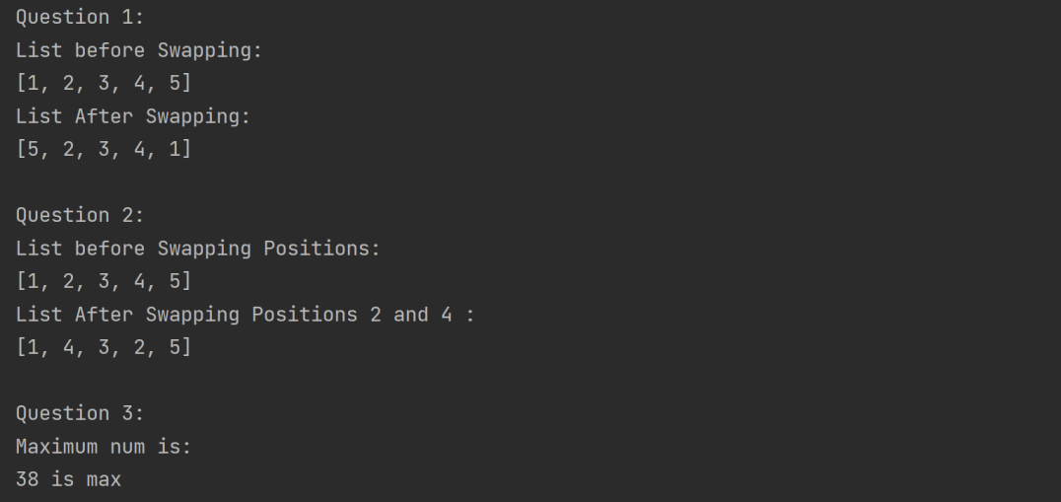

# Question 4:

print("Question 4:")

print("List Taken:")

list4 = [1, 2, 3, 4, 5, 6, 7, 8, 9, 10]

print(list4)

def odd_numbers_in_list(lis):

li = []

for i in lis:

if i % 2 != 0:

li.append(i)

print(li)

print("Odd numbers in the List are: ")

odd_numbers_in_list(list4)

print()

# Question 5:

print("Question 5:")

list5 = [-2, -5, -10, 0, 1, 2, 3, 4, 5]

print("List Taken: ")

print(list5)

def negative_numbers(lis):

li = []

for i in lis:

if i < 0:

li.append(i)

print(li)

print("Negative numbers in the List are : ")

negative_numbers(list5)

print()

OUTPUT FOR QUESTION 4, 5:

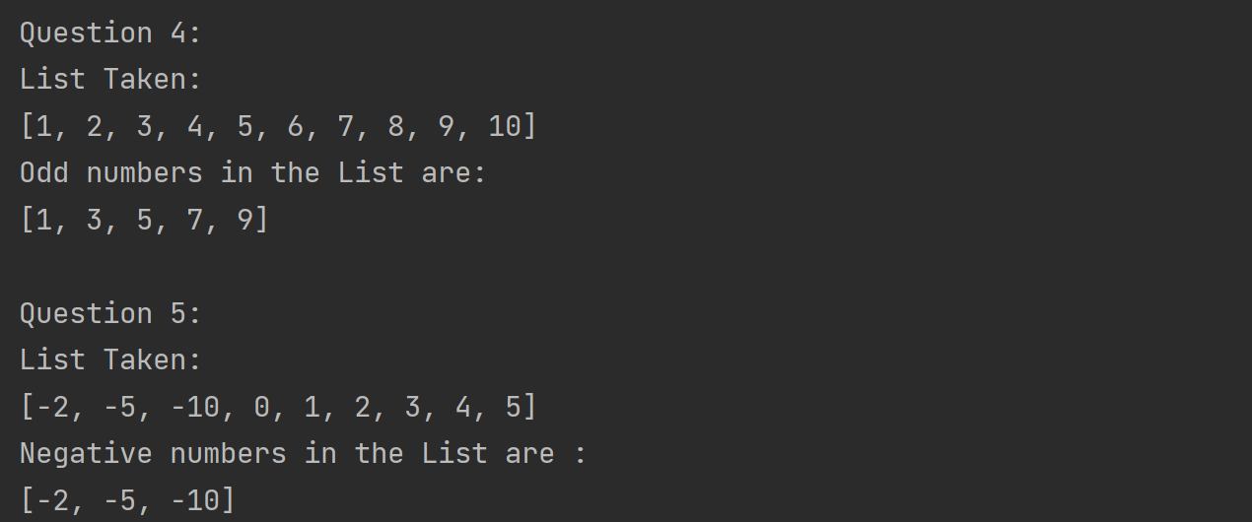

# Question 6:

# condition : remove even elements

print("Question 6:")

list6 = [1, 2, 3, 4, 5, 6, 7, 8, 9, 10]

print("List Taken:")

print(list6)

print("Condition : removing even elements")

def remove_even(lis):

for i in lis:

if i % 2 == 0:

lis.remove(i)

print(lis)

print("List after removing even numbers: ")

remove_even(list6)

print()

# Question 7:

# condition : remove elements divisible by 3:

print("Question 7:")

list7 = [1, 2, 3, 4, 5, 6, 7, 8, 9, 10]

print("List Taken:")

print(list7)

print("Condition : removing elements divisible by 3")

def remove_divisible_by_3(lis):

for i in lis:

if i % 3 == 0:

lis.remove(i)

print(lis)

print("List after removing numbers divisible by 3: ")

remove_divisible_by_3(list7)

print()

OUTPUT FOR QUESTION 6, 7:

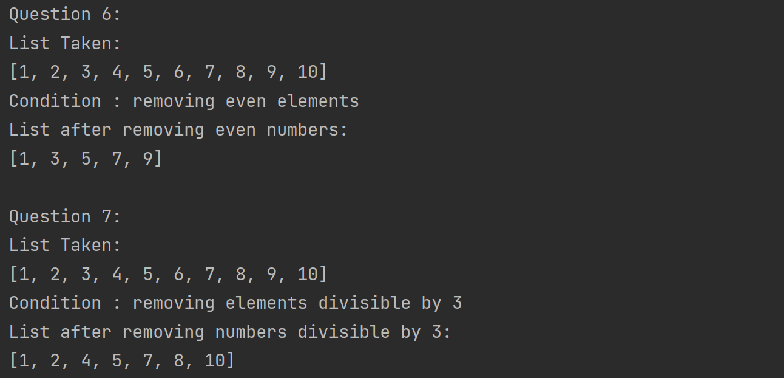

# Question 8:

print('Question 8:')

string1 = "rahul varma"

print("String Taken: ")

print(string1)

print()

def uppercase_of_later_part(stri):

a = len(stri)

string2 = ''

b = a // 2

string2 = string2 + stri[0:b]

string2 = string2 + stri[b:a].upper()

print(string2)

print("String after performing uppercase of later part: ")

uppercase_of_later_part(string1)

OUTPUT FOR QUESTION 8:

